## **Error Control**

Error Control is a technique of error detection and retransmission.

**Categories of Error Control:**

Data Link Controls

**Stop-and-wait ARQ**

Stop-and-wait ARQ is a technique used to retransmit the data in case of damaged or lost frames.

This technique works on the principle that the sender will not transmit the next frame until it receives the acknowledgement of the last transmitted frame.

**Four features are required for the retransmission:**

* The sending device keeps a copy of the last transmitted frame until the acknowledgement is received. Keeping the copy allows the sender to retransmit the data if the frame is not received correctly.
* Both the data frames and the ACK frames are numbered alternately 0 and 1 so that they can be identified individually. Suppose data 1 frame acknowledges the data 0 frame means that the data 0 frame has been arrived correctly and expects to receive data 1 frame.
* If an error occurs in the last transmitted frame, then the receiver sends the NAK frame which is not numbered. On receiving the NAK frame, sender retransmits the data.
* It works with the timer. If the acknowledgement is not received within the allotted time, then the sender assumes that the frame is lost during the transmission, so it will retransmit the frame.

**Two possibilities of the retransmission:**

* **Damaged Frame:** When the receiver receives a damaged frame, i.e., the frame contains an error, then it returns the NAK frame. For example, when the data 0 frame is sent, and then the receiver sends the ACK 1 frame means that the data 0 has arrived correctly, and transmits the data 1 frame. The sender transmits the next frame: data 1. It reaches undamaged, and the receiver returns ACK 0. The sender transmits the next frame: data 0. The receiver reports an error and returns the NAK frame. The sender retransmits the data 0 frame.
* **Lost Frame:** Sender is equipped with the timer and starts when the frame is transmitted. Sometimes the frame has not arrived at the receiving end so that it can be acknowledged neither positively nor negatively. The sender waits for acknowledgement until the timer goes off. If the timer goes off, it retransmits the last transmitted frame.

**Sliding Window ARQ**

SlidingWindow ARQ is a technique used for continuous transmission error control.

**Three Features used for retransmission:**

* In this case, the sender keeps the copies of all the transmitted frames until they have been acknowledged. Suppose the frames from 0 through 4 have been transmitted, and the last acknowledgement was for frame 2, the sender has to keep the copies of frames 3 and 4 until they receive correctly.
* The receiver can send either NAK or ACK depending on the conditions. The NAK frame tells the sender that the data have been received damaged. Since the sliding window is a continuous transmission mechanism, both ACK and NAK must be numbered for the identification of a frame. The ACK frame consists of a number that represents the next frame which the receiver expects to receive. The NAK frame consists of a number that represents the damaged frame.
* The sliding window ARQ is equipped with the timer to handle the lost acknowledgements. Suppose then n-1 frames have been sent before receiving any acknowledgement. The sender waits for the acknowledgement, so it starts the timer and waits before sending any more. If the allotted time runs out, the sender retransmits one or all the frames depending upon the protocol used.

**Two protocols used in sliding window ARQ:**

* **Go-Back-n ARQ:** In Go-Back-N ARQ protocol, if one frame is lost or damaged, then it retransmits all the frames after which it does not receive the positive ACK.

Three possibilities can occur for retransmission:

* **Damaged Frame:** When the frame is damaged, then the receiver sends a NAK frame.

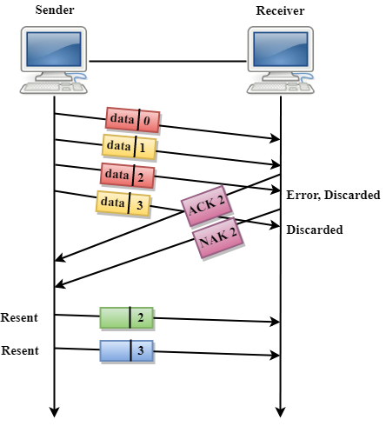

In the above figure, three frames have been transmitted before an error discovered in the third frame. In this case, ACK 2 has been returned telling that the frames 0,1 have been received successfully without any error. The receiver discovers the error in data 2 frame, so it returns the NAK 2 frame. The frame 3 is also discarded as it is transmitted after the damaged frame. Therefore, the sender retransmits the frames 2,3.

* **Lost Data Frame:** In Sliding window protocols, data frames are sent sequentially. If any of the frames is lost, then the next frame arrive at the receiver is out of sequence. The receiver checks the sequence number of each of the frame, discovers the frame that has been skipped, and returns the NAK for the missing frame. The sending device retransmits the frame indicated by NAK as well as the frames transmitted after the lost frame.
* **Lost Acknowledgement:** The sender can send as many frames as the windows allow before waiting for any acknowledgement. Once the limit of the window is reached, the sender has no more frames to send; it must wait for the acknowledgement. If the acknowledgement is lost, then the sender could wait forever. To avoid such situation, the sender is equipped with the timer that starts counting whenever the window capacity is reached. If the acknowledgement has not been received within the time limit, then the sender retransmits the frame since the last ACK.

**Selective-Reject ARQ**

* Selective-Reject ARQ technique is more efficient than Go-Back-n ARQ.
* In this technique, only those frames are retransmitted for which negative acknowledgement (NAK) has been received.
* The receiver storage buffer keeps all the damaged frames on hold until the frame in error is correctly received.
* The receiver must have an appropriate logic for reinserting the frames in a correct order.
* The sender must consist of a searching mechanism that selects only the requested frame for retransmission.

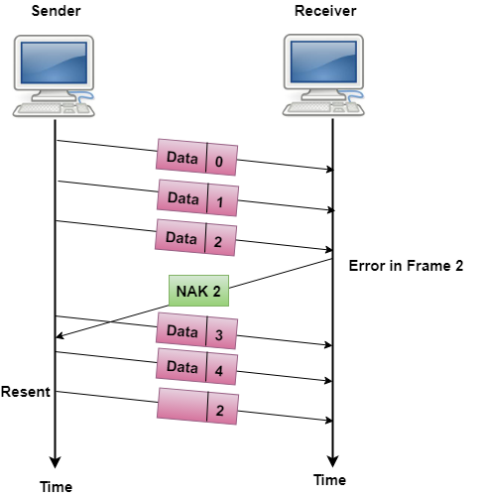

Stop and Wait Protocol

Before understanding the stop and Wait protocol, we first know about the error control mechanism. The error control mechanism is used so that the received data should be exactly same whatever sender has sent the data. The error control mechanism is divided into two categories, i.e., Stop and Wait ARQ and sliding window. The sliding window is further divided into two categories, i.e., Go Back N, and Selective Repeat. Based on the usage, the people select the error control mechanism whether it is **stop and wait** or **sliding window**.

What is Stop and Wait protocol?

Here stop and wait means, whatever the data that sender wants to send, he sends the data to the receiver. After sending the data, he stops and waits until he receives the acknowledgment from the receiver. The stop and wait protocol is a flow control protocol where flow control is one of the services of the data link layer.

It is a data-link layer protocol which is used for transmitting the data over the noiseless channels. It provides unidirectional data transmission which means that either sending or receiving of data will take place at a time. It provides flow-control mechanism but does not provide any error control mechanism.

The idea behind the usage of this frame is that when the sender sends the frame then he waits for the acknowledgment before sending the next frame.

### Primitives of Stop and Wait Protocol

**The primitives of stop and wait protocol are:**

**Sender side**

**Rule 1:** Sender sends one data packet at a time.

**Rule 2:** Sender sends the next packet only when it receives the acknowledgment of the previous packet.

Therefore, the idea of stop and wait protocol in the sender's side is very simple, i.e., send one packet at a time, and do not send another packet before receiving the acknowledgment.

### Receiver side

**Rule 1:** Receive and then consume the data packet.

**Rule 2:** When the data packet is consumed, receiver sends the acknowledgment to the sender.

Therefore, the idea of stop and wait protocol in the receiver's side is also very simple, i.e., consume the packet, and once the packet is consumed, the acknowledgment is sent. This is known as a flow control mechanism.

### Working of Stop and Wait protocol

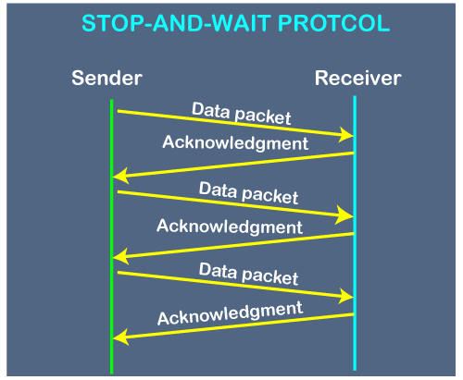

The above figure shows the working of the stop and wait protocol. If there is a sender and receiver, then sender sends the packet and that packet is known as a data packet. The sender will not send the second packet without receiving the acknowledgment of the first packet. The receiver sends the acknowledgment for the data packet that it has received. Once the acknowledgment is received, the sender sends the next packet. This process continues until all the packet are not sent. The main advantage of this protocol is its simplicity but it has some disadvantages also. For example, if there are 1000 data packets to be sent, then all the 1000 packets cannot be sent at a time as in Stop and Wait protocol, one packet is sent at a time.

### Disadvantages of Stop and Wait protocol

**The following are the problems associated with a stop and wait protocol:**

**1. Problems occur due to lost data**

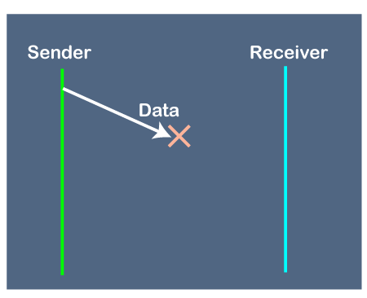

Suppose the sender sends the data and the data is lost. The receiver is waiting for the data for a long time. Since the data is not received by the receiver, so it does not send any acknowledgment. Since the sender does not receive any acknowledgment so it will not send the next packet. This problem occurs due to the lost data.

**In this case, two problems occur:**

* Sender waits for an infinite amount of time for an acknowledgment.
* Receiver waits for an infinite amount of time for a data.

**2. Problems occur due to lost acknowledgment**

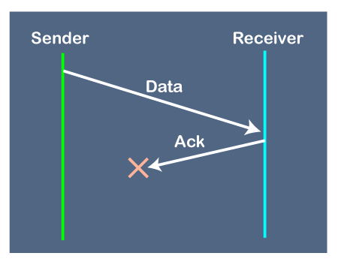

Suppose the sender sends the data and it has also been received by the receiver. On receiving the packet, the receiver sends the acknowledgment. In this case, the acknowledgment is lost in a network, so there is no chance for the sender to receive the acknowledgment. There is also no chance for the sender to send the next packet as in stop and wait protocol, the next packet cannot be sent until the acknowledgment of the previous packet is received.

**3. Problem due to the delayed data or acknowledgment**

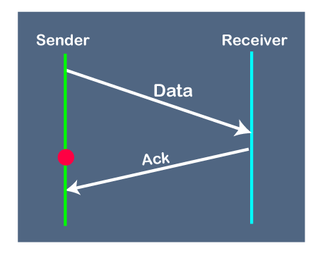

Suppose the sender sends the data and it has also been received by the receiver. The receiver then sends the acknowledgment but the acknowledgment is received after the timeout period on the sender's side. As the acknowledgment is received late, so acknowledgment can be wrongly considered as the acknowledgment of some other data packet.